COMICS AND THE GREAT WAR – COMPARISON OF A LETTER AND A COMIC
Henrik Smrekar, Črnovojnik/ The black soldier; Alojz Polh's letter

Introduction
The comparison of letters and comics can be a good example of how a scant words "come alive" through drawings, which makes the events more understandable for the proper study of clothes, arms, fashion, architecture of sometime ... The comic is an interpretation of an event - as A. Spiegelman says: “Writing stories is easier than drawing a comic - when someone writes that the character went home on this and this street, each reader imagines this differently. When I am creating a comic, I need to know exactly how this street will look like, in order to draw it convincingly enough for the viewer ...«
Writing letters is some kind of reporting from the scene of the event. Drawing comics is a visual study of all the circumstances belonging to this story. In the comics the author can add his comment, and communicate ideas with the style that is chosen for the drawings (caricature, realistic, stylized), with the way a determined expression on the face is drawn, the details on the dress, the hand gestures ... Text and picture are always going hand in hand in the comics. And in the good comics they will not be repeated - which means that if a character says something, the image may be an upgrade and not the only scarce portrait of action. At the same time, the comics can be as brief as a letter, which describes events of a few days in a few sentences. In comics this is achieved by a sequence of images that picture extracts from different periods.

1. What is the communicative value of the text and the story in the comics and what in the letter?
2. Which one has attracted you more and why?
3. What do you miss in the text (in the comisc and in the letter)?
4. Who were the comics and the letter intended for?
5. Which author do you think has a more honest view, and why?
6. Have both texts changed your view of the First World War? How?

Sources:
- The proto-comic Hinko Smrekar: Črnovojnik
http://www.europeana1914-1918.eu/sl/contributions/5094
- Alojz Polh’s final letter
www.rtvslo.si/prva-svetovna-vojna/iz-osebnih-arhivov

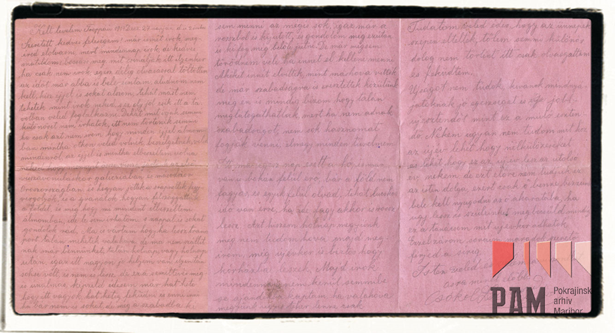

A letter from Alojzij Polh
22-years old Alojzij Poh from Barka in Brkini, today West Slovenia, was sent on the Easter front already in 1914. He was badly enjured soon after, his family was already infromed of his death, but they got his last letter from the Russian captivity.

Dragi brat! Draga Družina! Predragi starši! Naznanjam vam, da sem sedaj v drugi bolnišnici in da se mi je rana poslabšala. Oteklo mi je veliko krvi in gnoja in vode vmes. Morda mi ne bo več dolgo živeti. Upanje imam v Boga še vedno, da bom še videl ljube domače kraje. Ranjen sem bil dne 26. Avgusta. Že 42. dan sem na postelji. Ako bi bil vedno v eni bolnišnici, bi bil morda že ozdravel, ali vožnja me je poslabšala. Ranjen nisem bil hudo, ali kri in gnoj sta mi uničila nogo: 40 dni se cedi kri iz noge. Naj se zgodi božja volja. Morda so to moji zadnji pozdravi. Sprejmite mnogo poljubov in mnogo gorečih pozdravov – vsa družina in sorodniki in vsi domači fantje in dekleta od v voljo božjo vdanega Alojzija Polha. Še en poljub vsem! Z bogom, z bogom, z bogom, ljubi moj domači kraj! Če se ne vidimo, se bomo videli gori. Sprejmite še en poljub in mnogo gorečih pozdravov. Ako se več ne vidimo, ne žalujte. Morda pa me ljubi Bog še ohrani pri življenju in se še vidimo. Z bogom, ne žalujte!
– Alojzij Polh, Moskva, Nikolajska kasarna 442, 8. 10, 1914

Translation
Dear brother! Dear Family! Dearest parents! I want to tell you, that I am in another hospital now and that my wound got worse. I've lost a lot of blood and water, besides pus is oozing from the wound. Maybe I won't live much longer. I still pray to God that I will see my hometown once again. I was wounded on 26th August. I'm laying in a bed for the 42nd day now. If I were only in one hospital I would be better by now, but moving me to another hospital made my condition worse. My wound wasn't that bad, but blood and pus were the reason for spreading of the wound: blood has been dripping out of my leg for 40 days. Let the god's will happen. Maybe I'm sending you my last regards. Please accept a bunch of kisses and many loving goodbyes - all the family and relatives and all the hometown boys and girls from Alojzij Polh. Another kiss to you all! Goodbye, goodbye, goodbye, my dear hometown! If we don't see eachother again, we will meet again in heaven. Accept another kiss and a lot of warming regards. If we don't se eachother again, please don't mourn. Maybe God will keep me alive and we'll see eachother again. Farewell, don't mourn!

COMPARISON

The comic Črnovojnik (Black soldier) by Hinko Smrekar and soldier's letters

Črnovojniki, a protocomic book of Henrik Smrekar, is known as the beginner of Slovenian comic books. In this work the author draw and wrote about his sensations during the First World War in years 1914 and 1915. That time was a time of war absolutism, censorship, antislavic activity and suffering. Smrekar wanted to draw and write about all these sensations in form of caricature and satire. Because of the censorhip he could publish his work only in 1919. The war is presented in a wittily way, because he wanted to affect readers, so he describes catastrophic war conditions with humour. Caricatures fill up records and they represent more thoroughly the life back then. The author is subjective and partial in his portraits, because he describes his thoughts and feelings. The message of this comics is the nonsense of war. Hinko Smrekar has improved the development of Slovenian caricature and critical thinking. He also has risen up the Slovene caricature to a new level.
The three letters from soldiers, who were writing to their families and loved ones are describing how war was affecting men's lives on the front. One letter was from Alojzij Polh, a 22 year old soldier, who wrote to his family, telling them about his condition and about his wounded leg. In this letter we learned about medical conditions in hospitals during the first world war. The second letter was written by Žiga (Zsigmond) Janko. He was telling his wife about how much spare time he had on the front. We think that the letter was quite meaningless. He did show love for his wife, but the letter itself didn't tell us much about his situation. The last letter was from Alojz Gorup. We think that this letter isn't censored, because it is the only one that is not completely grammatically correct. There are also a lot of words from the northern slovenian dialect. He wrote to his mother, while remembering his father, thinking about everything that was going on in his life at that moment.
Both the comics and in the soldier's letters draw a portret of every day's life during First World War.
We see an read about health, medical procedures which were very painful, because in that time there was lack of medication and there was no anaesthesia during procedures. Both of the writers also included the faith in God, which kept the soldiers motivated during the hard times. We think that it was significant that they had someone to look up to and to find comfort, even though they were alone and sometimes in critical positions.
Reading the comiscs and letters didn't really give us any new information about the war, but it did give us the insight on the personal lives of the soldiers. It really got us thinking about how much pain and suffering our ancestors went through, even though they weren't there voluntarily.

