Celina Wiesker
- Remembrance poppies
- Commonwealth
- War Memorial
- Heroes Cult

Great Britain and the remembrance poppies
In all countries of the Commonwealth the remembrance poppies has become a symbol for all the deaths in the wars.
The roots of the remembrance poppies as a symbol lie in the poem “In Flanders Field” which was written by the Canadian pathologist and university professor, John A McCrae, who was stationed in the First Brigade of the Canadian Artillery during the First World War. The lyric poem “In Flanders Fields” is the reaction of John A. McCrae to the death of one of his friends, in May 1915. The poppies stand for the soldiers who had lost their lives on the battlefield and had spread blood all over it. After the publication of McCrae’s poem, many people started to use the remembrance poppies as a symbol, especially on Armistice Day or other occasion where they honoured veterans. The remembrance poppies can be found at nearly every war memorial in Great Britain that remembers the victims of war.
In 2015 the installation “Blood swept Lands and Seas of Red” was an act of memorizing the victims of the First World War. For the 100th anniversary of the First World War Paul Cummings and Tom Pieper have created a sea of red ceramic poppies around the tower of London. A line he found in a will of an unknown soldier who wrote inspired the artist “The blood swept lands and seas of red, where angels fear to tread...” each on of the ceramic poppies represented the life of one dead soldier. Every soldier in the Commonwealth who had died in the course of the First World War was included which made in total 888,246 ceramic poppies. The poppies were sold after the installation for 25 pounds and the profit was donated. The installation was rebuilt that day after Armistice Day and the poppies were packed up.
On the premiere of the James Bond movie “Spectre” Daniel Craig also wore a remembrance poppy, which shows that the symbol of the fallen soldiers is still used and common in the Commonwealth.
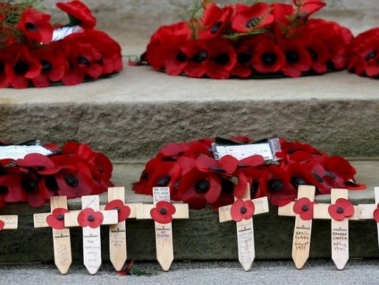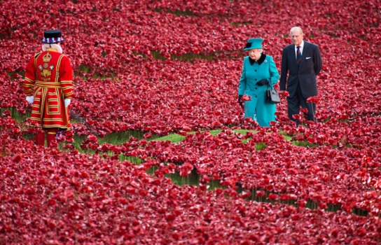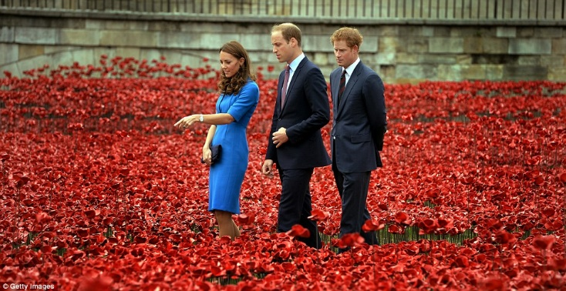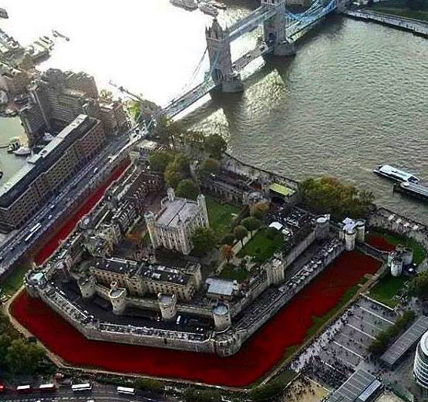
(http://www.ruhrnachrichten.de/storage/pic/mdhl/automatischer-bildimport/dpa/infoline/brennpunkte/636262_1_xio-image-4919d76293bdd.jpeg-2glq5856-20081111-img_19515570_original.large-4-3-800-184-0-2084-1427.jpg?version=1226430366)
http://www.theguardian.com/world/2014/dec/28/blood-swept-lands-story-behind-tower-of-london-poppies-first-world-war-memorial
(http://www.greatwar.co.uk/poems/john-mccrae-in-flanders-fields.htm)
http://www.huffingtonpost.de/simon-mcdonald/gedenkfeier-fur-kriegsgefallene-london-gedenkt-des-1-weltkriegs-mit-einem-meer-an-roten-mohnblumen_b_6131784.html)
httpoddstuffmagazine.comwp-contentuploads201410POPPY-queen_3086562k-650x419.jpg
httpi.dailymail.co.ukipix20140805article-2716788-2046DD6C00000578-800_964x497.jpg
httpsannecarolinedrake.files.wordpress.com201411poppyaerial.jpg

Tasks
- Find examples of Poppy Day being used by celebrities in the British media. (Recover, Find)
- Identify typical contexts of its use for political goals. (Synthesize)
- Analyse the symbolic character of the poppy against the background of the era of its origin. (Recover, Find, Deduct)

