Kuhlmann, Chiara
-American Propaganda Poster
-Stereotype of the enemy

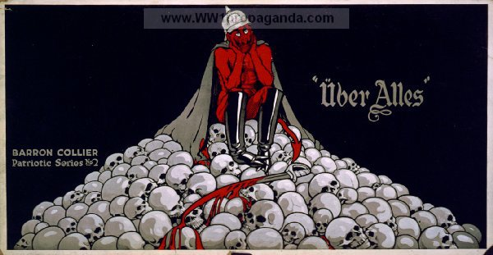
http://www.ww1propaganda.com/ww1-poster/%C3%BCber-alles

The propaganda poster was published in America in 1917. It shows the devil sitting on a pile of skulls and bloody swords. Next to the devil it says “Über Alles“. The general sense of this is “more important than everything else“.
The devil in the poster wears a spiked helmet which is a classical symbol for the German soldiers. These spiked helmets were worn by the Prussian army since 1843. Later, in the Franco-Prussian war the became a symbol for Prussian militarism. In the beginning of World War I it was still worn by the German soldiers, but in the course of the war they started to wear different helmets.
Portraying the German as the devil gives him an extremely negative character and it makes the people fear him. The devil is a supernatural creature different religions fear because it is the epitome of evil.
The skulls and the bloody swords the devil sits on show how many people the German have already killed. This makes him even more negative and dangerous.
Next to the devil the passage “Über Alles“ is written down. It is a famous passage from the “Deutschlandlied“, a song created by the German Hoffmann von Fallersleben in 1841. The original meaning of “Über Alles“ is that the creation of a German nation state is more important than everything else. In the poster it is abused by the American drawer to give the German the reputation of being the cruel and inconsiderate enemy that is only interested in his own country and people. For the German it does not matter that he killed a lot of people. He is the enemy to fear and he is as dangerous as the devil himself.

Tasks

Give an overview of what the poster shows. (Read and infer)
Describe the individual elements in detail. (Discriminate or differentiate)
Discuss the symbolic content of these details. (Analyse and interpret)
Explain the statement „Über Alles“ in the poster and its meaning. (Analyse and interpret)
Invent an alternative caption/title for the caricature. (Synthesize)

